Android UART Adapter Programming Guide

Version

Version | Author | Date | Digest
0.1 | Sean Chang | 2015-04-29 | Introduce UART Adapter API and working flow.

Contents

Android UART Adapter Programming Guide

Version

Contents
1. The application project 2
2. Application Source Code 3
3. Android NsdManager Class 4
3.1 Class Overview 4
3.2 Class operation flow chart 5
3.3 NsdManager Class API 6
4. UART Adapter working flow 8
4.1 Discover devices 9
4.2 Configure an Ameba device 10
4.3 2-Way char data transmission 11

1. The application project
The UART Adapter(UART Through) application project developed by Android Studio. Android Studio is an integrated development environment (IDE) for developing on the Android platform. An Android developer must install the Android Studio and then they could import and develop this project.

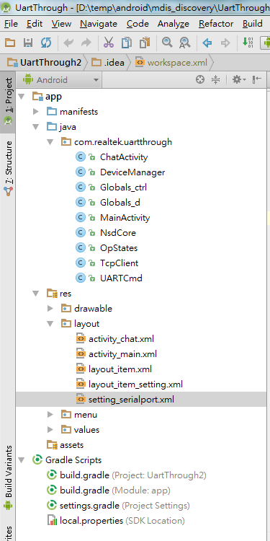
Figure 1-1 Application Structure
2
3
1

Description:
The main package name;
UART Adapter application source code;
Android layout xml file.

2. Application Source Code
The function of each application source code file( in Figure 1-1) is shown as Table 1-1

Table 1-1 Functions of application source code
File name | Description
ChatActivity.java | The class that implement the updating of chat UI component and status.
DeviceManager.java | The class that implement the management of device core information.
Globals_ctrl.java | The class that implement the core information of control socket.
Globals_d.java | The class that implement the core information of data socket.
MainActivity.java | The main demonstration Activity that calls all the other classes.
NsdCore.java | The class that implement the Network Service Discovery feature.
OpStates.java | The class that implement the status of operation.
TcpClient.java | The class that implement the TCP control and data client.
UARTCmd.java | The class that implement the definition of UART configuration.

3. Android NsdManager Class
java.lang.Object
- android.net.nsd.NsdManager

3.1 Class Overview
The Network Service Discovery Manager class provides the API to discover services on a network. As an example, if device A and device B are connected over a Wi-Fi network, a game registered on device A can be discovered by a game on device B. Another example use case is an application discovering printers on the network.

The API currently supports DNS based service discovery and discovery is currently limited to a local network over Multicast DNS.

The API is asynchronous and responses to requests from an application are on listener callbacks on a separate thread.

There are three main operations the API supports - registration, discovery and resolution.

3.2 Class operation flow chart
Register any local services to be advertised with registerService()
onServiceRegister()ed()
advertised with registerService()
onRegistrationFailed()
()
advertised with registerService()
remove service to list
st
onServiceLost()
()

add service to list
onServiceFound()

Application start
discoverServices()

Maintain a list to track discovered services
resolveService()

onServiceResolved()

Establish connection to service with the host and port information

3.3 NsdManager Class API
Nested Classes
interface | NsdManager.DiscoveryListener | Interface for callback invocation for service discovery
interface | NsdManager.RegistrationListener | Interface for callback invocation for service registration
interface | NsdManager.ResolveListener | Interface for callback invocation for service resolution

Constants
String | ACTION_NSD_STATE_CHANGED | Broadcast intent action to indicate whether network service discovery is enabled or disabled.
String | EXTRA_NSD_STATE | The lookup key for an int that indicates whether network service discovery is enabled or disabled.
int | FAILURE_ALREADY_ACTIVE | Indicates that the operation failed because it is already active.
int | FAILURE_INTERNAL_ERROR | Failures are passed with onRegistrationFailed(NsdServiceInfo, int), onUnregistrationFailed(NsdServiceInfo, int), onStartDiscoveryFailed(String, int), onStopDiscoveryFailed(String, int) oronResolveFailed(NsdServiceInfo, int).
int | FAILURE_MAX_LIMIT | Indicates that the operation failed because the maximum outstanding requests from the applications have reached.
int | NSD_STATE_DISABLED | Network service discovery is disabled
int | NSD_STATE_ENABLED | Network service discovery is enabled
int | PROTOCOL_DNS_SD | Dns based service discovery protocol

Public Methods
void | discoverServices(String serviceType, int protocolType, NsdManager.DiscoveryListener listener)  Initiate service discovery to browse for instances of a service type.
void | registerService(NsdServiceInfo serviceInfo, int protocolType, NsdManager.RegistrationListener listener)  Register a service to be discovered by other services.
void | resolveService(NsdServiceInfo serviceInfo, NsdManager.ResolveListener listener)  Resolve a discovered service.
void | stopServiceDiscovery(NsdManager.DiscoveryListener listener)  Stop service discovery initiated with discoverServices(String, int, NsdManager.DiscoveryListener).
void | unregisterService(NsdManager.RegistrationListener listener)  Unregister a service registered through registerService(NsdServiceInfo, int, NsdManager.RegistrationListener).

4. UART Adapter working flow
UART Adapter tool can be used to:
1. Discover devices;
2. Configure an Ameba device;
3. 2-way char data transmission.

4.1 Discover devices
The working flow of discover devices is shown as Fig 2-1.

startDiscover()
in MainActivity.java

new NsdCore object
()

NsdCore object initial method : initializeNsd()
()

NsdCore internal method:
initializeDiscoveryListener()
initializeResolveListener()
initializeRegistrationListener()

NsdCore.discoverServices (Globals_d.getServiceType())

NsdCore internal callback function: onServiceFound()

NsdCore internal callback function: onServiceRegistered ()

NsdCore internal callback function: onServiceResolved ()

Fig 2-1 The working flow of discover devices

4.2 Configure an Ameba device
The working flow of device configuration is shown as Fig 2-2.

btn_setting.setOnClickListener ()
in MainActivity.java
()

new TcpClient thread object and pass the Globals_ctrl instance
()

Execute TcpClient thread instance
()
Send request header
()
Get response frame from Ameba
Combine setting of configuration
Use setTx() to Send request setting
()
Get response frame from Ameba

Fig 2-2 The working flow of device configuration

4.3 2-Way char data transmission
The working flow of data transmission is shown as Fig 2-3.

onCreate () in ChatActivity.java
()
Use updateInfoDisplay () to update Chat UI: TextView

Run rxThread () to receive char data

gridView.setOnItemClickListener ()
()

new TcpClient thread object and pass the Globals_d instance
()

Execute TcpClient thread instance
()

Use updateInfoDisplay () to update Chat UI: TextView
Use setTx() to Send char data

Fig 2-3 The working flow of data transmission.

